Test Automation and Test Automation Frameworks

1-Test Automation

🔹 Definition
# Source: AI Source: Provided by: [Data Path: Persons Table -> ID Column: 1, Name_En Column: Motasem Essam] -> From: [ChatGPT] on [8/25/2025]
Test Automation is the process of using software tools to execute test cases automatically, compare actual results with expected results, and report outcomes, instead of performing tests manually.
It is widely used for repetitive, regression, or large-scale testing to improve efficiency, accuracy, and speed.

🔹 Purpose / Why Use Test Automation
# Source: AI Source: Provided by: [Data Path: Persons Table -> ID Column: 1, Name_En Column: Motasem Essam] -> From: [ChatGPT] on [8/25/2025]
- Reduce manual effort in repetitive testing.
- Increase test coverage by running more tests in less time.
- Detect defects earlier in the development lifecycle.
- Improve accuracy by eliminating human errors.
- Support continuous testing in Agile and DevOps environments.
- Enable faster regression testing after each code change.

🔹 Key Features
# Source: AI Source: Provided by: [Data Path: Persons Table -> ID Column: 1, Name_En Column: Motasem Essam] -> From: [ChatGPT] on [8/25/2025]
- Automation of functional, regression, integration, and end-to-end tests.
- Scriptable or record/playback testing.
- Support for cross-browser, cross-platform, and mobile testing.
- Integration with CI/CD pipelines for continuous testing.
- Reporting of pass/fail results and defect logging.

🔹 Examples of Test Automation Tools
# Source: AI Source: Provided by: [Data Path: Persons Table -> ID Column: 1, Name_En Column: Motasem Essam] -> From: [ChatGPT] on [8/25/2025]
- Selenium → Web application automation.
- Cypress → Modern end-to-end testing for web apps.
- Appium → Mobile app testing (iOS & Android).
- UFT (Unified Functional Testing) → Desktop and web apps.
- TestComplete → GUI and API automation testing.
- Playwright → Cross-browser web testing.

🔹 Example in Practice
# Source: AI Source: Provided by: [Data Path: Persons Table -> ID Column: 1, Name_En Column: Motasem Essam] -> From: [ChatGPT] on [8/25/2025]
- An e-commerce app requires daily regression testing.
- Testers automate 200 test cases using Selenium.
- After each code commit, tests run automatically in CI/CD pipelines.
- Any failures automatically create defects in Jira, saving manual reporting time.

✅ In short:
Test Automation is about automating repetitive or complex testing tasks using tools to save time, reduce errors, increase coverage, and support continuous delivery.

what is Benefits and Risks of Test Automation

Benefits of Test Automation
# Source: AI Source: Provided by: [Data Path: Persons Table -> ID Column: 1, Name_En Column: Motasem Essam] -> From: [ChatGPT] on [8/25/2025]
- Faster Execution
  - Automated tests run much faster than manual testing, especially for repetitive tests or regression testing.
  - Can execute large test suites overnight or in parallel across multiple environments.
- Improved Test Coverage
  - Automation allows testing of more scenarios, inputs, and data combinations than feasible manually.
  - Helps ensure edge cases are tested consistently.
- Repeatability and Consistency
  - Tests can be repeated exactly the same way every time.
  - Reduces human error in executing test cases.
- Early Defect Detection
  - Automated tests can run continuously (e.g., in CI/CD pipelines), detecting issues immediately after code changes.
  - Supports practices like Continuous Testing and Test-Driven Development (TDD).
- Cost Savings in the Long Term
  - Although initial setup costs are high, automation reduces manual effort over time.
  - Ideal for regression tests that need to be repeated frequently.
- Improved Accuracy
  - Removes the chance of human mistakes in repetitive tasks.
  - Provides precise results and logs for debugging.
- Supports Agile and DevOps
  - Enables faster feedback loops, allowing developers to fix issues sooner.
  - Integrates with CI/CD pipelines for continuous integration and delivery.

Risks of Test Automation
# Source: AI Source: Provided by: [Data Path: Persons Table -> ID Column: 1, Name_En Column: Motasem Essam] -> From: [ChatGPT] on [8/25/2025]
- High Initial Investment
  - Requires tools, licenses, skilled personnel, and setup time.
  - Not cost-effective for small or short-term projects.
- Maintenance Overhead
  - Automated tests break if the application UI or functionality changes frequently.
  - Test scripts need constant updates, which can become time-consuming.
- False Sense of Security
  - Automated tests only verify what’s scripted.
  - Critical defects outside the automated scenarios might be missed.
- Limited Flexibility
  - Hard to automate tests requiring human judgment, visual checks, or complex exploratory scenarios.
  - Not all test cases are suitable for automation.
- Tool and Skill Dependence
  - Success depends on selecting the right tool and having skilled testers/developers.
  - Incorrect tool choice may lead to inefficiency or failed automation projects.
- Complex Setup for Dynamic Systems
  - Highly dynamic, real-time, or frequently changing applications are harder to automate.
  - Integration with other systems may require additional scripting effort.

✅ Summary:
Automation is highly beneficial for repetitive, high-volume, regression, and performance tests, but it comes with cost, maintenance, and coverage limitations. The key is balancing manual and automated testing based on project needs.

2-Test Automation Frameworks

🔹 Definition
# Source: AI Source: Provided by: [Data Path: Persons Table -> ID Column: 1, Name_En Column: Motasem Essam] -> From: [ChatGPT] on [8/25/2025]
A Test Automation Framework is a structured set of guidelines, standards, and tools used to design, develop, and execute automated tests efficiently and consistently.
It provides a foundation and structure for automating tests rather than writing individual scripts haphazardly.

🔹 Purpose / Why Use a Framework
# Source: AI Source: Provided by: [Data Path: Persons Table -> ID Column: 1, Name_En Column: Motasem Essam] -> From: [ChatGPT] on [8/25/2025]
- Standardize test automation across teams and projects.
- Promote code reusability and reduce duplication.
- Improve maintainability of automated test scripts.
- Integrate easily with CI/CD pipelines, test management, and reporting tools.
- Enhance readability and scalability of automated tests.

🔹 Key Features
# Source: AI Source: Provided by: [Data Path: Persons Table -> ID Column: 1, Name_En Column: Motasem Essam] -> From: [ChatGPT] on [8/25/2025]
- Structured folder and script organization.
- Predefined reusable functions or libraries.
- Standardized reporting and logging mechanisms.
- Easy integration with CI/CD, version control, and defect tracking.
- Support for data-driven, keyword-driven, modular, or hybrid testing approaches.

🔹 Common Types of Test Automation Frameworks
# Source: AI Source: Provided by: [Data Path: Persons Table -> ID Column: 1, Name_En Column: Motasem Essam] -> From: [ChatGPT] on [8/25/2025]
- Linear / Record & Playback Framework
  - Simple, records user actions and replays them.
  - Best for small projects.
  - Tools: Selenium IDE, UFT record/playback mode.
- Modular Testing Framework
  - Test scripts are divided into independent modules or functions.
  - Each module can be reused in multiple test cases.
- Library Architecture Framework
  - Uses libraries of common functions to reduce script redundancy.
- Data-Driven Framework
  - Test data is separated from scripts (Excel, CSV, DB).
  - Allows running the same test with multiple data sets.
- Keyword-Driven Framework
  - Uses keywords to represent actions (click, input, validate).
  - Non-technical users can create tests using keywords.
- Hybrid Testing Framework
  - Combines multiple frameworks (data-driven + keyword-driven + modular) for flexibility.

🔹 Example in Practice
# Source: AI Source: Provided by: [Data Path: Persons Table -> ID Column: 1, Name_En Column: Motasem Essam] -> From: [ChatGPT] on [8/25/2025]
- A banking app requires login testing for multiple users and scenarios.
- Using a Data-Driven Framework:
  - Login script is written once.
  - Usernames, passwords, and expected outcomes are stored in Excel.
  - Framework reads data and executes the same script for all users automatically.
- Results are logged and reported, defects are automatically linked to Jira.

✅ In short:
A Test Automation Framework provides structure, reusability, and maintainability for automated testing, making it easier to manage large-scale automated test suites efficiently.

🧩 Comparison of Test Automation Frameworks
# Source: AI Source: Provided by: [Data Path: Persons Table -> ID Column: 1, Name_En Column: Motasem Essam] -> From: [ChatGPT] on [8/25/2025]
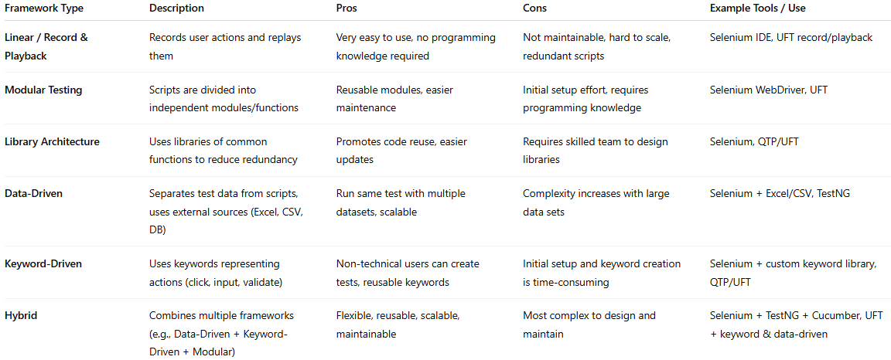

Framework Type | Description | Pros | Cons | Example Tools / Use
Linear / Record & Playback | Records user actions and replays them | Very easy to use, no programming knowledge required | Not maintainable, hard to scale, redundant scripts | Selenium IDE, UFT record/playback
Modular Testing | Scripts are divided into independent modules/functions | Reusable modules, easier maintenance | Initial setup effort, requires programming knowledge | Selenium WebDriver, UFT
Library Architecture | Uses libraries of common functions to reduce redundancy | Promotes code reuse, easier updates | Requires skilled team to design libraries | Selenium, QTP/UFT
Data-Driven | Separates test data from scripts, uses external sources (Excel, CSV, DB) | Run same test with multiple datasets, scalable | Complexity increases with large data sets | Selenium + Excel/CSV, TestNG
Keyword-Driven | Uses keywords representing actions (click, input, validate) | Non-technical users can create tests, reusable keywords | Initial setup and keyword creation is time-consuming | Selenium + custom keyword library, QTP/UFT
Hybrid | Combines multiple frameworks (e.g., Data-Driven + Keyword-Driven + Modular) | Flexible, reusable, scalable, maintainable | Most complex to design and maintain | Selenium + TestNG + Cucumber, UFT + keyword & data-driven

🔹 Quick Tips
# Source: AI Source: Provided by: [Data Path: Persons Table -> ID Column: 1, Name_En Column: Motasem Essam] -> From: [ChatGPT] on [8/25/2025]
- Linear / Record & Playback → Good for small projects or prototypes.
- Modular / Library Architecture → Good for medium to large projects with reusable functionality.
- Data-Driven / Keyword-Driven → Best when multiple datasets or non-technical testers are involved.
- Hybrid → Best for enterprise-level automation, combining flexibility, maintainability, and scalability.

🆚 Test Automation vs Test Automation Frameworks
# Source: AI Source: Provided by: [Data Path: Persons Table -> ID Column: 1, Name_En Column: Motasem Essam] -> From: [ChatGPT] on [8/25/2025]
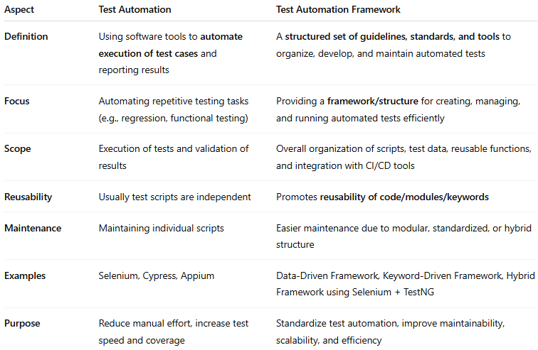
Aspect | Test Automation | Test Automation Framework
Definition | Using software tools to automate execution of test cases and reporting results | A structured set of guidelines, standards, and tools to organize, develop, and maintain automated tests
Focus | Automating repetitive testing tasks (e.g., regression, functional testing) | Providing a framework/structure for creating, managing, and running automated tests efficiently
Scope | Execution of tests and validation of results | Overall organization of scripts, test data, reusable functions, and integration with CI/CD tools
Reusability | Usually test scripts are independent | Promotes reusability of code/modules/keywords
Maintenance | Maintaining individual scripts | Easier maintenance due to modular, standardized, or hybrid structure
Examples | Selenium, Cypress, Appium | Data-Driven Framework, Keyword-Driven Framework, Hybrid Framework using Selenium + TestNG
Purpose | Reduce manual effort, increase test speed and coverage | Standardize test automation, improve maintainability, scalability, and efficiency

🔹 Key Insight
# Source: AI Source: Provided by: [Data Path: Persons Table -> ID Column: 1, Name_En Column: Motasem Essam] -> From: [ChatGPT] on [8/25/2025]
- Test Automation is the act of automating tests.
- Test Automation Frameworks are the structured approach that organizes and supports that automation efficiently.
- Think of it like this:
  - Test Automation = writing and running automated tests.
  - Framework = the rules, structure, and reusable components that make those tests easier, faster, and maintainable.

Visual diagram showing Test Automation inside a Framework
# Source: AI Source: Provided by: [Data Path: Persons Table -> ID Column: 1, Name_En Column: Motasem Essam] -> From: [ChatGPT] on [8/25/2025]
